AUTHOR: David Shi

First you need to insert your

consumer_key

consumer_secret

access_key

access_secret

These info can be acquired from the Twitter API page in your account settings.

Section 1:

Uncomment the code in Section 1.

This part of the script is able to send tweets with or without images

If you want to send a tweet without an image:

Use new_tweet and replace "Test with twitter API" with the text you want to post

Comment the other two lines

Run the script

Here is a resulting image from a test:

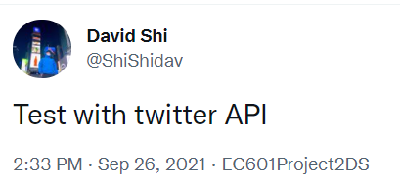

If you want to send a tweet with an image:

Comment the new_tweet line

Uncomment the other two lines

Replace "Test with twitter API" with the text you want to post, and the “image.png” with the image you want to post

Run the script

Here is a resulting image from a test:



Section 2:

Comment Section 1 and uncomment Section 2

This part of the script can show the info of the first 20 posts of your own Twitter timeline in a table including:

The text content, source, retweet count, language, favorite count, user id, source url, user and author name

Here is a resulting image from a test:

